22.65: a) The charge enclosed:
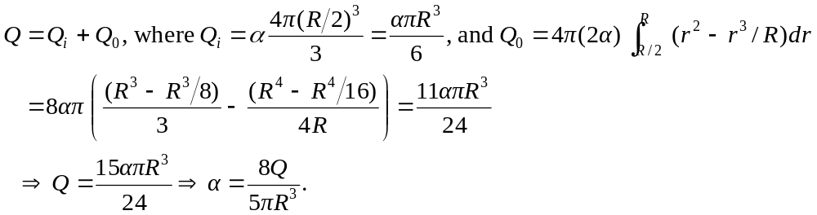
b) 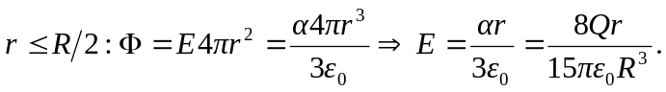
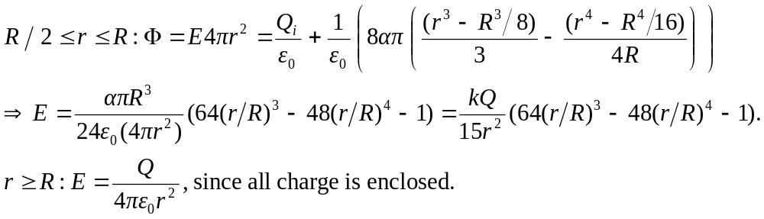
c) 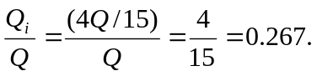
d) 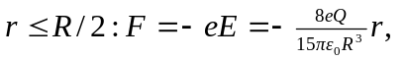so the restoring force depends upon displacement to the first power, and we have simple harmonic motion.
e) 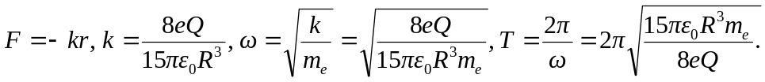
f) If the amplitude of oscillation is greater than 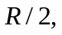 the force is no longer linear in 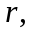 and is thus no longer simple harmonic.

